**CHAPTER 1**

**INTRODUCTION**

**1.1INTRODUCTION**

Online examinations, sometimes referred as e-examinations, are the examinations conducted through the internet or in an intranet (if within the organization) for a remote candidate(s). Most of the examinations issue results as the candidate finish the examination, when there is an answer processing module also included with the system. Candidate is given a limited time to answer the questions after the time expiry the answer paper is disabled automatically and answers to send the examiner. The examiner will evaluate the answers, either through automated process or manually and the results will be sent to the candidate through email or made available in the website. Today many organizations are conducting online examinations worldwide successfully and issue results online.

There areadvantages and disadvantages in online examinations. The main advantage is that it can be conducted for remote candidates and evaluations of answers can be fully automated for MCQ questions. Also online examination can be conducted at any time and does not incur high cost as traditional exam scenario as there is no paper work involved, there is no invigilators, also no need of arrangement of exam centers. When comparing with traditional exam scenario the cost of an online examination will be almost zero after the online exam system establishment and if maintenance cost is not considered.

The disadvantage of the e-examination is the inability of invigilating. There are methodologies used in these examinations, when registering candidates and presentation of questions, so that to test candidates knowledge and skills. However with a limited time, candidate cannot be completely tested with his skill-test.

Online Examination System is very useful for Educational Institute to prepare an exam, safe the time that will take to check the paper. It will help the Institute to testing of students and develop their skills. But the disadvantages for this system, it takes a lot of times when you prepare the exam at the first time for usage. And we are needs number of computers with the same number of students. In this web application student can give exams and view their results.

The effective use of "Online Examination System", any Educational Institute or training centers can be use it to develop their strategy for putting the exams, and for getting better results in less time.

1.2 BRIEF BACKGROUND OF THE ORGANIZATION

Convergence Software Solutions is a software development company founded way back in 2008, having developed high-performance database applications and web based software solutions. The company deploys, maintains and develops software customized to their client’s requirement. They ensure flexible and scalable solutions for their customers, to allow any future re-development. Their features are:

* AMC( Annual Maintenance Contract)
* Search Engine Optimization
* Web Analytics
* Email Marketing
* Web Hosting and Domain Registration
* Customized Software Solutions
* Customized Portals or Web Applications
* E-commerce Solutions
* Mobile Application.

**1.3 PROJECT TITLE**

The project was titled as **“ONLINE EXAMINATION SYSTEM”**.

**1.4PROBLEM DEFINATION**

The **“ONLINE EXAMINATION SYSTEM”**is used to provide a next generation online platform for the admin to conduct exams and users to appear exams.

**1.5 EXISTING SYSTEM**

Today have the problem for going to far away Exam Centre. Students need to wait for their results. Examiners are not able to maintain the student record in large quantity.Manipulation of student record is difficult for examiners and another problem of sending question paper one place to another place. And have a problem of change the choice of option which is not possible in paper. And have the problem of leaking paper before examination but this problem will not born in online examination system.

**1.6 PROPOSED SYSTEM**

Online Examinations is very helpful to users. The aim of this project is to provide quick, immediate and easy way to appear the exam. It can provide special advantages to the students. The online examination system can automatically add the marks allocated in each questions. A time limit can be set for the questions. And user can also print their results. Admin will register students and give them username and passwords to login and appear the exam. This system will provide result after the exam according to correct and wrong answer. In this system admin will enter the exam name, duration, questions, options, marks per question.

**1.7 OBJECTIVES**

General objective of this web application is to change the current manual system into computerized one. The primary objectives are

* Responses by the candidates will be checked automatically.
* It reduces time consumption.
* Being an integrated online examination system reduce paper work.
* Questions can have multiple options.
* The result will be shown immediately to the participating student.
* This system will enable educational institutes to conduct test and have automated checking answers based on the response by the candidates.

**1.8 SCOPE OF THE SYSTEM**

Scope of this project is very broad in terms of other manually taking exams. Few of them are:-

* This can be used in educational institutions as well as in corporate world.
* Can be used anywhere any time as it is a web based application (user location doesn’t matter).
* Design to facilitate administrator and user.
* Online examination is designed for educational institutes like schools, colleges and private institutes to conduct logic tests of their students or employees on regular basis

**1.9 HARDWARE AND SOFTWARE USED**

Platform used: Windows7

Hardware used: Intel CORE i3 processor(3rd generation)

4GB RAM

500GB HDD

Software used: Adobe Dreamweaver CS6

Front end: CSS, PHP

Scripting Language: JavaScript

Web Server: Apache Tomcat Server

Backend: My Sql

**CHAPTER 2**

**REQUIREMENT ANALYSIS**

**2.1 INTRODUCTION**

In the requirement analysis we conduct one to one interview to find out requirement of the system. Here we talk with all the officials of Convergence Software Solutions to find the loopholes of the existing system. The goal of system development meant to deliver the system in line with user’s requirement, and analysis is the heart of this process. The outcome is system specification that initiates system design.

The most crucial phase of the system development life cycle is the identification of need. There is a user’s request to change, improve or enhance an existing system. The initial investigation provides the objective to determine whether the user’s request is valid and feasible before a recommendation is reached to do nothing, to improve or to modify the existing system or to build a new one.

Requirement analysis is usually the first phase of software development project. In case the requirements are not clear, e.g. for a system the purpose of this phase is to identify and document the exact requirements for the system. As never been done before, many interactions are required between the user and developer.

**2.2 INFORMATION REQUIREMENT**

**2.2.1 INTRODUCTION**

In an attempt to study the existing system several loop holes was found and due to this the proposed system will help many users, the loop holes that were found during the investigation were:

* Identify customer’s needs.
* Evaluate system for feasibility.
* Perform economic and technical analysis.
* Allocate functions to system elements.
* Establish schedule and constraints.
* Create system definitions.

**2.2.2 NEEDS IDENTIFICATION**

The needs that were identified when studying the existing system seemed to make the task of giving solution quite easy and less time consuming. The needs that the application to be developed should possess were as follows:

* System requirement Analysis can be a challenging phase, because all of the major customers and there are brought into the process of determining requirements.
* Accurately identified requirements results from effective communication and collaboration of all members of the project team and providing a good system.
* The primary goal of this phase is to create a detailed functional specification defining the full set of system capabilities to be implemented.
* It is of utmost importance that the project team create a complete and accurate representation of all requirements that the system must accommodate.

**2.2.3 INFORMATION GATHERING**

This activity typically involves interviewing the end user and customers and studying the existing documents to collect all possible information. There are many tools a system analyst may use the most frequently used tools are:

* Conducting some census over various projects
* Questionnaires.
* Group Consensus.
* On- site Observation.
* Reviewing and deriving data from an existing system.

In this project information was mainly gathered through interviews, Questionnaires, on-site observation and through the study of the disadvantages of the existing system.

**2.3 SOFTWARE REQUIREMENT SPECIFICATION**

Client does not understand the software and the software development process, and the developer does not understand the client’s application area and problem, SRS is a medium through which clients and user’s needs are understood accurately by the developer and specified in the domain of software. A good SRS should satisfy all the three parties.

A second important purpose of developing SRS is helping the clients and users to understand their precise requirements. The process of developing SRS by involving the clients and users in the process provides an opportunity to them to think about their problems in new directions. This makes them to think objectively, visualize, interact and discuss with others and hence identify the precise requirements. The SRS document usually contains all the user requirements in structured though informal form.

**CHAPTER 3**

**FEASIBILITY ANALYSIS**

**3.1 INTRODUCTION**

Feasibility study is carried out to check the workability of the candidate system. Feasibility study is the testing of the proposed system according to its workability, impact on the organization, ability to meet the user needs and effective user resources.

There are three key considerations involved in the feasibility analysis. They are:

* Economic Feasibility
* Technical Feasibility
* Behavioral Feasibility

**3.1.1 ECONOMIC FEASIBILITY**

Economic feasibility is the most frequently used method for evaluating the effectiveness of the candidate system. In economic Feasibility, which is also known as cost benefit analysis, benefit expected from the candidate system is compared with cost. If the benefit outweighs cost, then the decision is made to design and implement the system. Otherwise, further justification or alteration in the proposed system will have to be made.

The proposed “Online Examination System” has many cost advantage over the existing traditional system. Benefit derived from the proposed system is much more than the cost to implement the system and so can accept it to be economically feasible.

**3.1.2 TECHNICAL FEASIBILITY**

We can strongly say that it is technically feasible, since there will not be much difficulty in getting required resources for the development and maintaining the system as well. All the resources needed for the development of the software as well as the maintenance of the same is available and we are utilizing the resources which are available already. According to feasibility analysis procedure the technical feasibility of the system is analyzed and the technical requirements such as software facilities, procedures, and inputs are identified. It is also one of the important phases of the system development activities. The system offers greater level of user friendliness, combined with greater processing speed. Therefore, the cost of maintenance can be reduced. Since processing speed is very high and the work is reduced in the maintenance point of view that the system is operationally feasible.

**3.1.3 BEHAVIORAL FEASIBILITY**

In this study, a judgment has to be made as to how strong a reaction the user is likely to have towards the development of an online system for learning. In general, people resistant to change and computer have been known to facilitate change. A survey should be made of how strong a reaction the users are likely to have towards the development of computerized system.

As more and more people are purchasing PC or mobiles with internet facilities, the attitude towards the candidate system seems to be positive. Also, the interest and support showed by the users during the system study doesn’t seem to reflect any probable resistance in this regard. So, we can assume the proposed system to be behaviorally feasible.

**3.2 CONCLUSION**

From the observation made in the feasibility study described above, it was recommended that proposed system is completely feasible for its development and implementation.

**CHAPTER 4**

**STRUCTURED ANALYSIS**

**4.1 INTRODUCTION**

System analysis is a detailed study of the various operation performed by a system and their relationship within and outside the system. It is a systematic technique that refines goals and objectives. The goal of system development is to deliver the system in line user requirement and analysis is the heart of this process. One of the best approaches to the system analysis is the structured analysis.

Structured analysis is a set of technique and graphical tools that allow us to develop new kind of specifications that is easily understandable to the developer. It is the detailed step by step investigation of the related procedure to see what must be done and to determine the best way of doing it. The objective is to build a system specification that provides the basis for design and implementation.

A Gantt chart is a system planning tool. It is basically a bar chart that shows the tasks of a system, when each must take place and how long each will take. As the system progresses, bars are shaded to show which tasks have been completed.

Gantt charts are useful for planning and scheduling system development. They help us assess how long a project should take, determine the resources needed, and plan the order in which you'll complete tasks. They're also helpful for managing the dependencies between tasks.

Gantt charts are useful for monitoring development progress once it's underway, too. We can immediately see what should have been achieved by a certain date and, if the project is behind schedule, you can take action to bring it back on course. The Gantt chart used during planning and scheduling phase is as follows:

Analysis and Specification

Design

Coding and Unit Testing

Integration and System testing

Maintenance

Aug 1

Aug 20

Sep 30

Oct 15

Nov20

Nov 30

Dec 10

**4.2 TOOLS USED IN STUCTURED ANALYSIS**

The various tools of structured analysis are:

* Data Flow Diagram
* Data Dictionary
* E-R Diagram

**4.2.1 DATA FLOW DIAGRAM**

As the information moves through the system, it is modified by a series of transformations. A Data Flow Diagram (DFD) is a graphical technique that depicts information flow and the transformations that are applied as the data moves from input to output. A DFD may be used to represent a system at any level of abstraction. DFD’s may be partitioned into levels that represent increasing information flow and functional details. A Level – 0 Level DFD, also called Context Diagram, represents the entire system as a single bubble with input and output data indicated by incoming and outgoing arrows respectively. Additional processes and information flow paths are represented as the Level – 0 is partitioned to reveal more details.

The basic notations to create DFD are illustrated as follows:

|  |  |
| --- | --- |
| SYMBOLS | DETAILS |
|  | External entity: The producer or the consumer of information that reside outside the bounds of the system is to be modeled. |
|  | Process:Transformation of information residing within the bounds of the system is to be modified. |
|  | Data Flow: The flow of data is denoted by arrows. The arrowhead indicates the direction of flow of data. |
|  | Data Store: A repository of data that is to be stored for use by one or more processes may be simple buffer or sophisticated database. |

The Data Flow Diagrams – 0-level, 1st level and 2nd level for the proposed system are as follows:

Response

Response

USER

ADMIN

ONLINE EXAMINATION SYSTEM

Get result

Appear exam

Login

Login

Student entry

Course entry

Subject entry

Question entry

Conduct exam

**Fig: 0 level DFD**

0.1 Login

0.7 Result

0.5Question Entry

0.6 Appear Exam

0.4Exam Entry

0.3 Student Entry

0.2 Master Entry

ADMIN

Login

Exam

Student

Subject

Course

USER

Appear Exam

Question

Report

**Fig: 1 Level DFD**

Request to log in

Request to log in

Response

Response

Request to add course and subject

Response

Response

Response

Response

Response

Response

Request to add student

Request to add exam

Request to add question

Request to appear exam

Request to view result

Retrieve course info

Retrieve subject info

Retrieve course info

Retrieve exam info

Retrieve question info

Retrieve exam info

Retrieve appear exam info

Response

Retrieve student info

Retrieve exam info

Retrieve student info

**Fig: 2nd level DFD**

Course

2.1 Add Course

ADMIN

2.2 Edit Course

2.3Add Subject

2.4 EditSubject

3.1 AddStudent

3.2 EditStudent

Subject

Student

4.1 AddExam

4.2 EditExam

Exam

5.1 AddQuestion

5.2 EditQuestion

Question

Request to add course

Request to edit course

Request to add subject

Request to edit subject

Request to add student

Request to edit student

Request to add exam

Request to edit exam

Request to add question

Request to edit question

Response

Response

Response

Response

Response

Response

Response

Response

Response

Updated course information

Updated subject information

Updated student information

Updated exam information

Updated question information

**4.2.2 DATA DICTIONARY**

Data dictionary is a structured repository of data, which provides detailed information about the data flowing among functions and to or from data stores. It is a set of rigorous definitions of all DFD data elements and data structures used to develop the application. It serves as a valuable document to the organization for future enhancement. Centralizing all definitions in the dictionary removes the danger to duplications and inconsistencies. During implementation, it serves as a common base against which programmers who are working on the system compare their data descriptions. Also control information maintained for each data element is cross-referenced in the Data Dictionary.

Most database management system has a Data Dictionary as a standard feature. Three classes are to be defined in a Data Dictionary. They are:

* Data elements: It is the smallest unit of data that provide for no further decomposition.
* Data structure: It is a group of data element handled as a unit.
* Data flows & Data stores: They are data structures in motion and data structures at rest respectively.

In constructing the Data Dictionary the analyst have to consider several points:

* Each data flow in the DFD has one Data Dictionary entry.
* Definitions must be readily accessible by name.
* There should not be data redundancy in the data definition.
* The procedures for writing definition should be precise.

The data dictionary of the proposed “**ONLINE EXAMINATION SYSTEM**” is as follows:

|  |  |  |  |
| --- | --- | --- | --- |
| **Sl. No.** | **Field name** | **Field description** | **Source table** |
| 1 | uname | User name | adminlogin |
| 2 | password | Password | adminlogin |
| 3 | cid | Course id | course |
| 4 | cname | Course name | course |
| 5 | sid | Subject id | subject |
| 6 | sname | Subject name | subject |
| 7 | sid | Student id | std |
| 8 | name | Student name | std |
| 9 | vill | Village | std |
| 10 | po | Post office | std |
| 11 | pin | Pin number | std |
| 12 | dist | District | std |
| 13 | state | State | std |
| 14 | dob | Date of birth | std |
| 15 | phno | Phone number | std |
| 16 | uname | User name | std |
| 17 | password | password | std |
| 18 | eid | Exam id | exam |
| 19 | ename | Exam name | exam |
| 20 | edate | Exam date | exam |
| 21 | duration | Duration | exam |
| 22 | locat | Location | exam |
| 23 | qid | Questions Serial no | questions |
| 24 | qno | Question no | questions |
| 25 | question | Question | questions |
| 26 | op1 | Option 1 | questions |
| 27 | op2 | Option 2 | questions |
| 28 | op3 | Option 3 | questions |
| 29 | op4 | Option 4 | questions |
| 30 | ans | Answer | questions |
| 31 | marks | Marks | questions |
| 32 | examid | Serial no | result |
| 34 | sname | Student name | result |
| 35 | marks | Marks | result |
| 36 | percentage | Percentage | result |
| 37 | result | Result | result |

**4.2.3 E-R DIAGRAM (ENTITY RELATIONSHIP DIAGRAM)**

Relationship Diagram represents the relationship between various entities and their attributes. Relationship between entities makes up a data structure. There are three types of relationship we can find in an ERD.

* One to one
* One to many
* Many to many

Symbols used in E-R diagram are as follows:

|  |  |
| --- | --- |
|  | Entity |
|  | Weak entity |
|  | Relationship |
|  | Attribute |
|  | Key attribute |
|  | Composite attribute |
|  | Identifying relationship |
|  | Multivalued attribute |
|  | Derived attribute |

STUDENT

SUBJECT

QUESTION

RESULT

EXAM

COURSE

sid

GET

name

vill

dist

pin

po

uname

phno

dob

state

password

question

ename

edate

etime

duration

locat

op1

ans

op4

op3

op2

eid

q_no

qid

marks

sname

sid

cname

cid

HAVE

HAVE

CONSIST OF

APPEAR

1

n

1

n

1

n

n

1

n

1

examid

percentage

marks

sname

result

**Fig: Entity Relationship Diagram**

**4.3 DATABASE DESIGN**

Usually, a collection of interrelated data is as database. The database contains information about one particular enterprise. Database system is to stair and manages large volume of information. The management of data involves both the definition structure of the storage of information and provision for manipulation information. In addition the database system must provide for safety of the information stored in the database, despite system crashes or unauthorized access.

The list of tables of the proposed system is given below:

1. **adminlogin**

|  |  |  |  |
| --- | --- | --- | --- |
| **FIELDS** | **DATA TYPES** | **SIZE** | **CONSTRAINTS** |
| uname | Varchar | 50 | Primary key |
| password | Varchar | 50 |  |

1. **course**

|  |  |  |  |
| --- | --- | --- | --- |
| **FIELDS** | **DATA TYPES** | **SIZE** | **CONSTRAINTS** |
| cid | Int | --- | Primary key |
| cname | Varchar | 50 |  |

1. **subject**

|  |  |  |  |
| --- | --- | --- | --- |
| **FIELDS** | **DATA TYPES** | **SIZE** | **CONSTRAINTS** |
| sid | Int | --- | Primary key |
| cid | Int | --- | Foreign key |
| sname | Varchar | 45 |  |

1. **std**

|  |  |  |  |
| --- | --- | --- | --- |
| **FIELDS** | **DATA TYPES** | **SIZE** | **CONSTRAINTS** |
| sid | Int | --- | Primary key |
| sname | Varchar | 45 |  |
| vill | Varchar | 45 |  |
| po | Varchar | 45 |  |
| pin | Double | --- |  |
| dist | Varchar | 45 |  |
| state | Varchar | 45 |  |
| cid | Int | --- | Foreign key |
| dob | Date | --- |  |
| phno | Double | --- |  |
| uname | Varchar | 45 |  |
| password | Varchar | 45 |  |

1. **exam**

|  |  |  |  |
| --- | --- | --- | --- |
| **FIELDS** | **DATA TYPES** | **SIZE** | **CONSTRAINTS** |
| eid | Int | --- | Primary key |
| ename | Varchar | 45 |  |
| cid | Int | --- | Foreign key |
| sid | Int | --- | Foreign key |
| edate | Date | --- |  |
| etime | Varchar | 45 |  |
| duration | Varchar | 45 |  |
| locat | Varchar | 45 |  |

1. **questions**

|  |  |  |  |
| --- | --- | --- | --- |
| **FIELDS** | **DATA TYPES** | **SIZE** | **CONSTRAINTS** |
| qid | Int | --- | Primary key |
| qno | Int | --- |  |
| eid | Int | --- | Foreign key |
| question | Varchar | 500 |  |
| op1 | Varchar | 500 |  |
| op2 | Varchar | 500 |  |
| op3 | Varchar | 500 |  |
| op4 | Varchar | 500 |  |
| ans | varchar | 500 |  |
| marks | Double | --- |  |

1. **result**

|  |  |  |  |
| --- | --- | --- | --- |
| **FIELDS** | **DATA TYPES** | **SIZE** | **CONSTRAINTS** |
| examid | Int | --- | Primary key |
| sname | Varchar | 50 |  |
| eid | Int | --- | Foreign key |
| marks | Int | --- |  |
| percentage | decimal | 10,2 |  |
| result | Varchar | 45 |  |

**CHAPTER 5**

**SYSTEM DESIGN**

**5.1 INTRODUCTION**

System design is a solution, “how to approach to the creation of new system?” .This important phase is composed of several steps. It provides understanding and procedural details necessary for implementing the system recommended in the feasibility study. Emphasis’s on translating the performance requirements into design specification.

**5.2 DESIGN STRATEGY**

The design strategy is the vital aspect of the system to be developed. The system design is essentially a blueprint or a plan for a solution for the system. The design of the system describes the final system and processes by which it is developed. It refers to the technical specifications that will be applied in implementing the system. It also includes the construction of the program testing. The goal of the design process is to produce a model or representation of a system, which can be used later to build that system. The product made is called the design of the system.

While designing the new system one has to consider many factors. These factors include the drawbacks and limitations of the present system as well as proposed features and the advantages of the system. It should be designed in such a way that a non-professional man can use it without any difficulty, i.e. the system should be use friendly. User friendliness can be achieved by providing visualizations effects, menus and context help the system. The design of the system should be such that a little change made in the system should not affect the entire system. This is a measure if flexibility, greater the system flexibility greater will be system reliability. In order to achieve speed efficiency the programs should be designed accordingly.

**5.3 TYPES OF DESIGN**

Design goes through logical and physical system stages of development. Logical design review the present physical system, prepare input and output specification, make edit and control specification, details the implementation plan and prepares logical design walkthrough. The physical design maps out details of the physical system, plans the system implementation, device a test implementation, and specifies any new software and hardware. System design goes through two phases of development:

**5.3.1 LOGICAL DESIGN**

We know that the data flow and diagram shows the logical flow of a system and define the boundaries of the system. Logical designs specify the user needs at a level of details that virtually determines the information flow into and out of the system and the required data resources. Logical design describes the inputs, outputs, databases and procedures all in a format. This meets the user requirements.

**5.3.2 PHYSICAL DESIGN**

It provides the working system and defining specifications that tells the programmers exactly what the candidate system must do. In short, it can state that physical design is the implementation of the logical design.

Physical system design consists of the following step:

* Design the physical system
* Specify the input/output media.
* Design the database and specify back up procedures.
* Design physical information flow through the system and physical design walkthrough.

**5.4 PLANNED SYSTEM IMPLEMENTATION**

System design involves the following designs:

* Input design
* Output design
* Database design
* Form design

**5.4.1 INPUT DESIGN**

Input design is a crucial part of any system design. Inaccurate input data are most important common cause of errors in data processing. Data entry errors can be controlled by input design. Input design is the process of converting user-oriented input to computer-based format. The goal of designing input data is to make data entry as easy, logical and free from errors as possible.

While entering data operations it is needed to know the following:

* The allocated space for each field.
* Field sequences which most match that in the source document.
* The formats in which the data fields are entered.

Keeping in view the user’s requirements, the input screens have been designed and developed for easy error free data entry. Base on the various types of inputs to be fed to the computer in using the proposed system, all input screens are of the fill in the blank types and messages are given to guide the data entry operator step-by-step.

**5.4.2 OUTPUT DESIGN**

Computer output is the most important and direct source of information to the users. Efficient intelligible output design should improve the system relationships with the user and help in design making. In the system under consideration, the output can be seen on the screen in the predefined format.

**5.4.3 DATABASE DESIGN**

Usually, a collection of interrelated data is referenced to as database. The database contains information about one particular enterprise. Database system is designed to stir and manage large volume of information. The management of data involves both the definition structures of the storage of information and provision for the manipulation of information. In addition the database system must provide for safety of the information stored in the database, despite system crashes or unauthorized access.

**5.4.4 FORM DESIGN**

A form is the physical carrier of data. It can carry authority for action. In designing a form, attention is given to proper identification and wording, read ability and use, composition and layout, order of data items and clarity of instructions.

**5.4.5 SCREENSHOTS**

Some of the screenshots for the proposed system are as follows:

1. Admin login

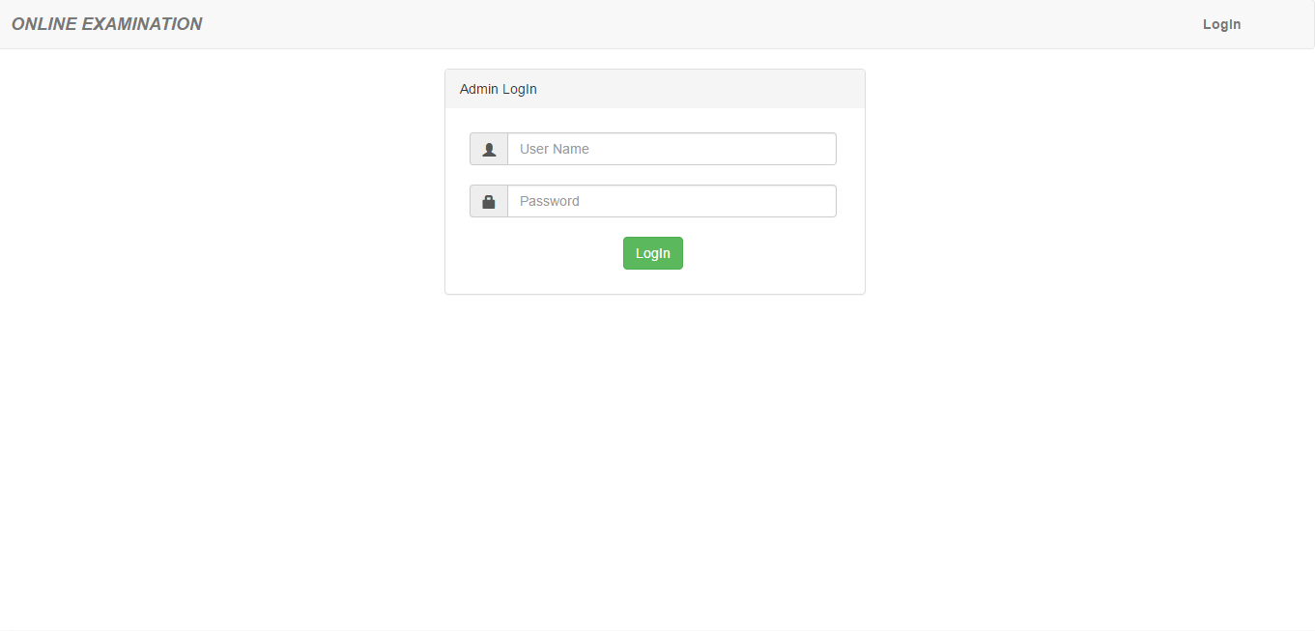

1. Admin home page



1. Course Entry

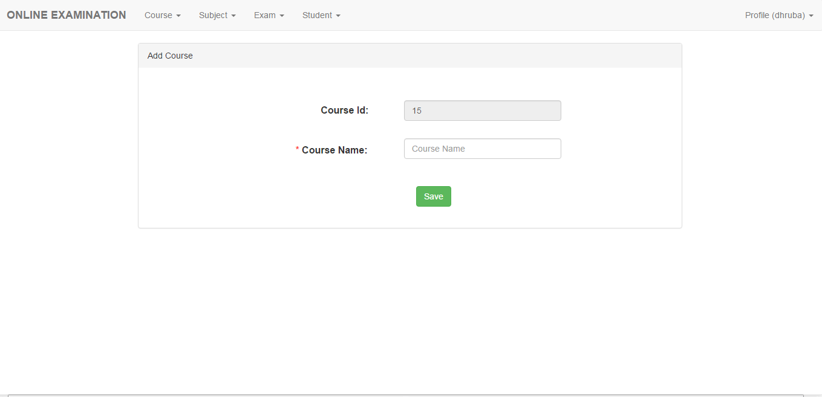

1. Subject Entry

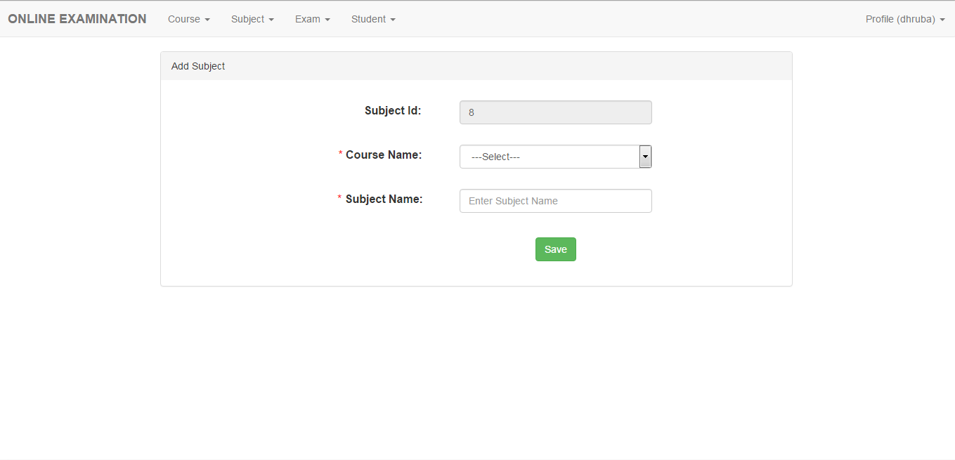

1. Student Entry

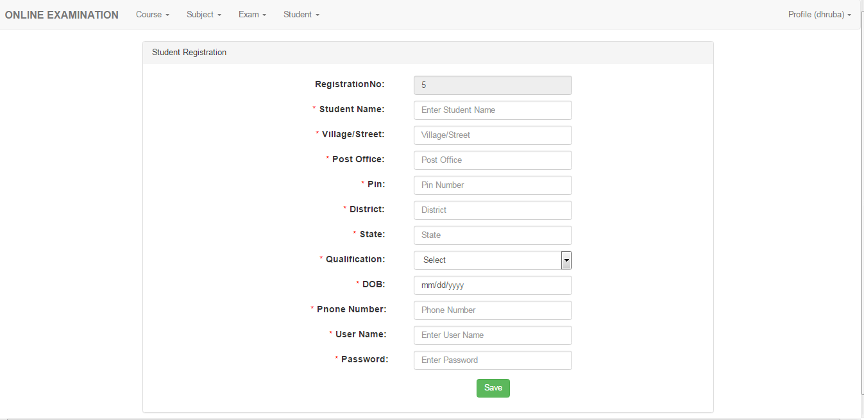

1. Exam Entry

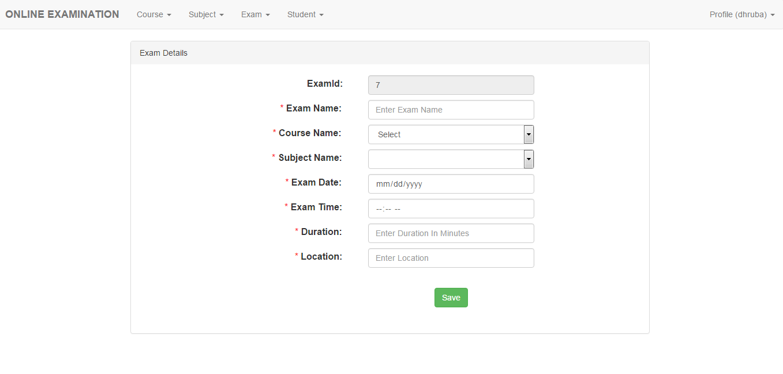

1. Question Entry

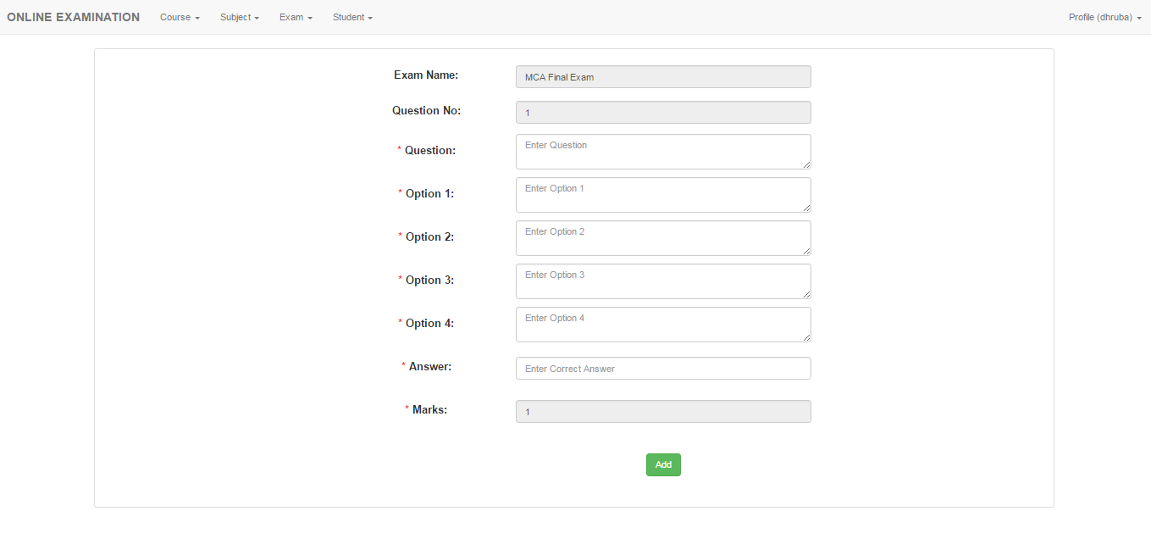

1. User Login

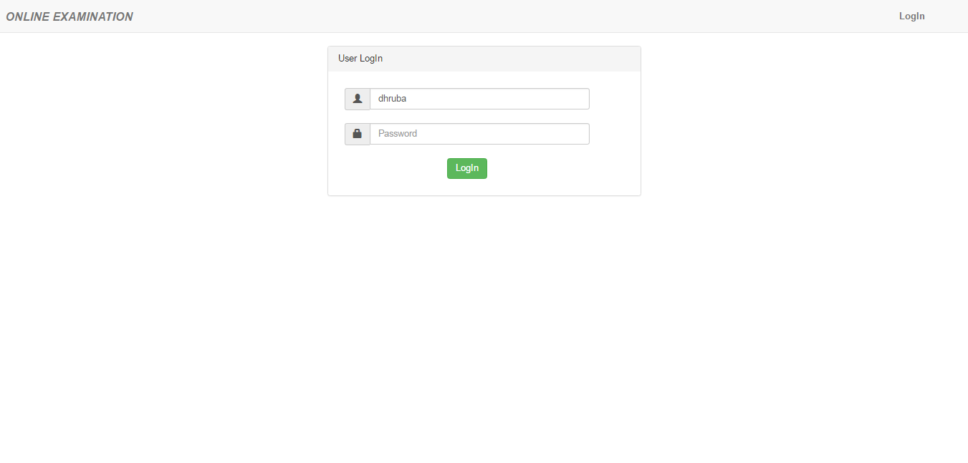

1. User Home

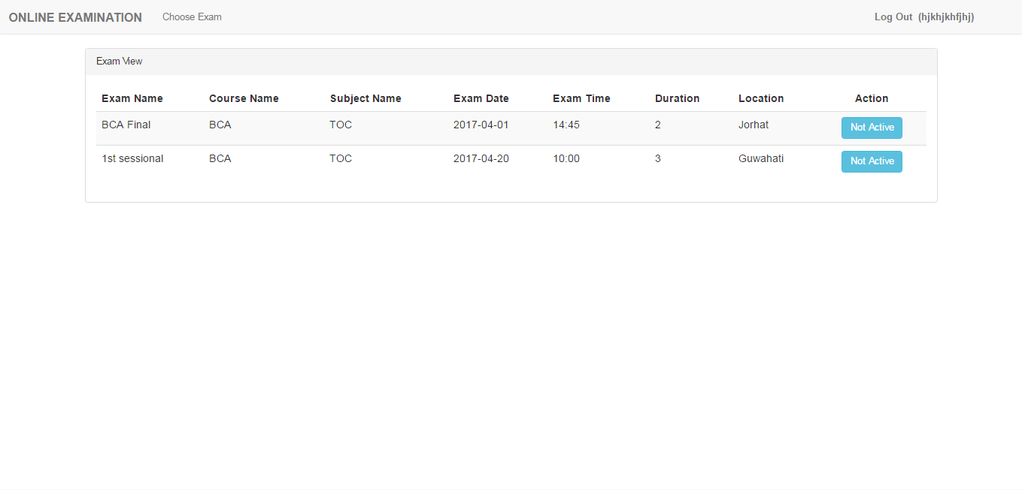

**CHAPTER 6**

**TESTING**

**6.1 INTRODUCTION**

No program or system design is perfect, communication between the user and the designer is not always complete or clear, and time is usually short. The result is errors and more errors. Theoretically, a newly designed system should have all pieces in working order, but in reality, each piece works independently. Now is the time to put all the pieces into one system and test it to determine whether it meets the user requirements. This is the last chance to detect and correct errors before the system is installed for user acceptance testing. The purpose of system testing is to consider all the likely variations to which it will be subjected and then push the system to limits. It is tedious but a necessary step in system development.

**6.2 TEST DATA**

Preparation of the test data plays an important role in the system testing. In case the test data are not properly designed, the system designer may not be able to find some flaws in the system and may have a misconception of having a perfect system, which may not be in reality. For the purpose of testing the system, instead of using live data, which may not fulfill the purpose, a sizeable number of synthetic data having specially set data values, were created so as to test each and every aspect of the system function properly after implementation.

**6.3 DEFINITION OF TESTING**

The process of analyzing a software item is to detect the difference between existing and required conditions and to evaluate the features of the software item. Or we can say that testing is a process of analyzing a program with the intent of finding errors.

**6.4 TYPES OF TESTING**

The different types of testing technique to be used during development of the system under consideration are as follows:

* **VALIDATION TESTING:** Software validation is achieved through a series of black-box tests that demonstrate conformity with requirements. A test plan outlines the classes of test to be conducted and a test procedure defines specific test cases that will be used to demonstrate conformity with requirements. Validation test is succeeded when the expectation of user is fulfilled completely.

In “ONLINE EXAMINATION SYSTEM” proper validation testing is done. For logging in, the user must provide valid user id and password otherwise an error message will be displayed.

* **INTEGRATION TESTING:** It is a systematic technique for construction of the program structure while at the same time conducting test to uncover error associated with interfacing. The objective is to take unit-tested module and built a program structure that has been dedicated by design.
* **UNIT TESTING:** Unit testing verifies the smallest module of the software designed. Using this testing the entire module can be debugged very easily. The relative complexity of test and errors detected as a result is limited by the constrained scrap establish for unit testing. The unit test is always white box oriented and the step can conduct in parallel for multiple modules. Unit testing is considered as adjunct to the coding step. After source code has been developed and verified for the syntax correction, unit test case design starts.
* **USER ACCEPTANCE TESTING:** This is considered to be more important as the users are not aware of the process inside the system. Proper validations and messages are needed to inform users during each mistake they make. Also necessary help is required to be given to the users for each time they are confused.

In “ONLINE EXAMINATION SYSTEM” whenever the user tries to insert any blank fields into the system and mismatch the name, phone number, email format, an error message is displayed.

**CHAPTER 7**

**CONCLUSION AND FUTURE SCOPE**

**7.1 CONCLUSION**

This web application provides facility to conduct online examinations foreducational institutions. It saves time as it allow number of students to give the exam at a time and displays the results as the test test gets over, so no need to wait for the result. It is automatically generated by the application.

Administrator has to create, modify and delete the test papers and its particular question. User can login and give the test with his specific id, and can see the results as well.

**7.2 FUTURE WORK**

Developments in software technology are continuing dynamically. This has forced developers to look for new approaches to design and development. In order to face this solution, the modules in a package should be upgraded any time. The modules in this package can be subjected to farther enhancements. Such as

* Upgradable to descriptive questions and answers.
* Developed discussion forums.
* Implementation on clouds server.
* Multimedia feature supports.
* Integrate learning material.

**CHAPTER 8**

**BIBLOGRAPHY**

1. ELMASRI, R. & NAVATHE, IN FUNDAMENTALS OF DATABASE SYSTEMS (5TH EDITION), PEARSON.
2. <https://www.w3schools.com>
3. <https://www.stackoverflow.com>
4. <https://www.google.co.in>
5. <https://www.bootsnipp.com>
6. <https://www.getbootstrap.com>